ELEC-2110

Electric Circuit Analysis

FROM: Jacob Howard

TO: Markus Kreitzer

DATE: September 18, 2019

LAB SECTION: 002

***Electrical Measurements:***

***Thevenin Equivalent Circuits***

# Introduction

The Objective of this lab was to review and work with Thevenin’s and Norton’s theorems. We used black boxes with unknown circuits inside to test and confirm Thevenin’s and Norton’s theorems.

# Exercise 1

In exercise 1, we were asked to show the mathematical derivation for how we know the voltage at two nodes will be VOC/2 when a resistor, Rload, is connected to those nodes that is equal to RTh [1]. Calculations shown in Calculations 1.

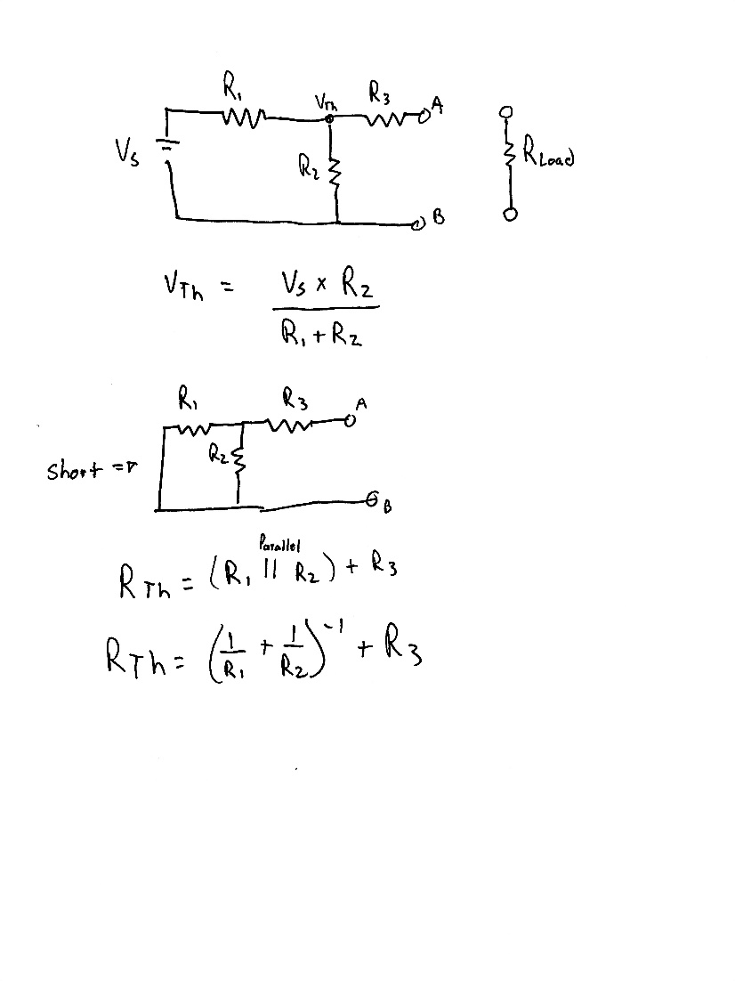

*Calculations 1*

# Exercise 2

In exercise 2, we were asked to measure and record the resistance between pin1 - pin2 and between pin2 – pin3 of your variable resistor [1]. The data is shown in Table 1 below.

|  |  |
| --- | --- |
| **Pin1 & Pin2** | 2.025 kΩ |
| **Pin2 & Pin3** | 8.0577 kΩ |
| **Pin1 & Pin3** | 9.8577 |
| **Sum of Pins 1&2 and Pins 2&3** | 10.0877 kΩ |

*Table 1*

# Exercise 3

In exercise 3, we were asked to experimentally determine the Thevenin equivalent circuit for the black box at terminals B1-B2. We were told to connect the 15V supply on the NI ELVIS Board to terminals A1-A2 as shown in the schematic in Figure. Turn on the component box and [1]

* Measure the voltage of the power supply on the NI ELIVIS Board
* Measure the voltage at terminals B1 - B2, which would be Voc.
* Calculate Voc/2
* Measure the voltage drop across the variable resistor as you vary its resistance.
* Measure the variable resistor’s resistance, which is RTh.

Each of these steps will be repeated for each unknown circuit box, so they will be labeled accordingly below. The voltage from the Elvis board will be constant (Vs  = 15.656V).

*Box 1 Measured Data*

|  |  |
| --- | --- |
| **Voc** | 5.2121 V |
| **Voc/2** | 2.605 V |
| **Voc/2 measured** | 3.6045 V |
| **Voltage drop from B1 – B2** | 10.44 V |
| **RTh** | 5.3194 kΩ |

|  |  |
| --- | --- |
| **Voc** | 15.617 V |
| **Voc/2** | 7.8085 V |
| **Voc/2 measured** | 7.8001 V |
| **RTh** | 1.9938 kΩ |

*Box 2 Measured Data*

*Box 3 Measured Data*

|  |  |
| --- | --- |
| Voc | -3.1239 |
| Voc/2 | -1.56195 |
| Voc/2 measured | -1.5632 |
| RTh | 1.204 kΩ |

# Exercise 4

In exercise 4, we were asked to open the boxes of unknown circuits, draw the circuits with Thevenin and Norton equivalent. We then used the equivalent circuits to calculate [1]. Each circuit is labeled for the appropriate box. (Note that each resistor is 2kΩ and Vs is 15.656 V)

*Box 1*

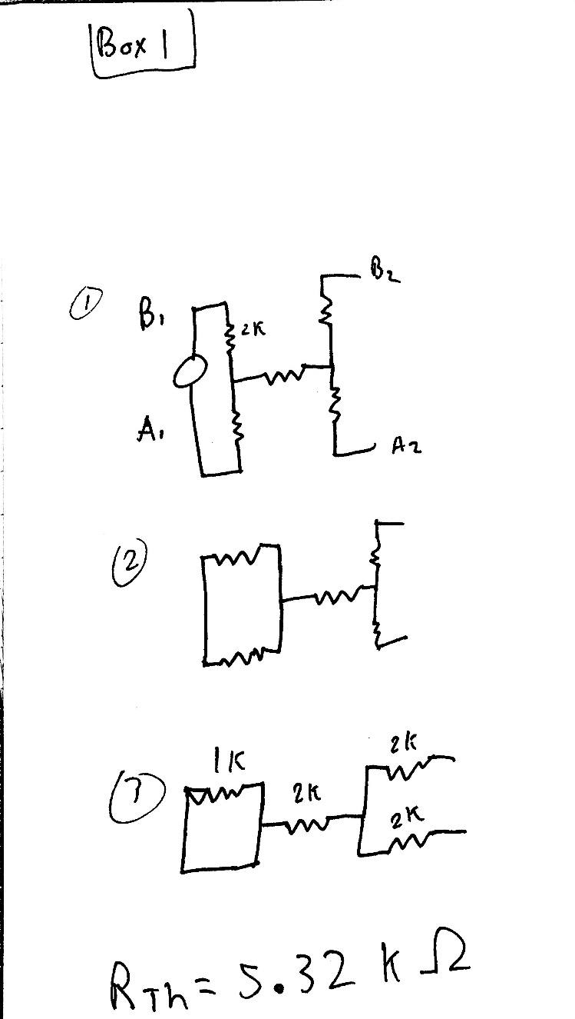

*Box 2*

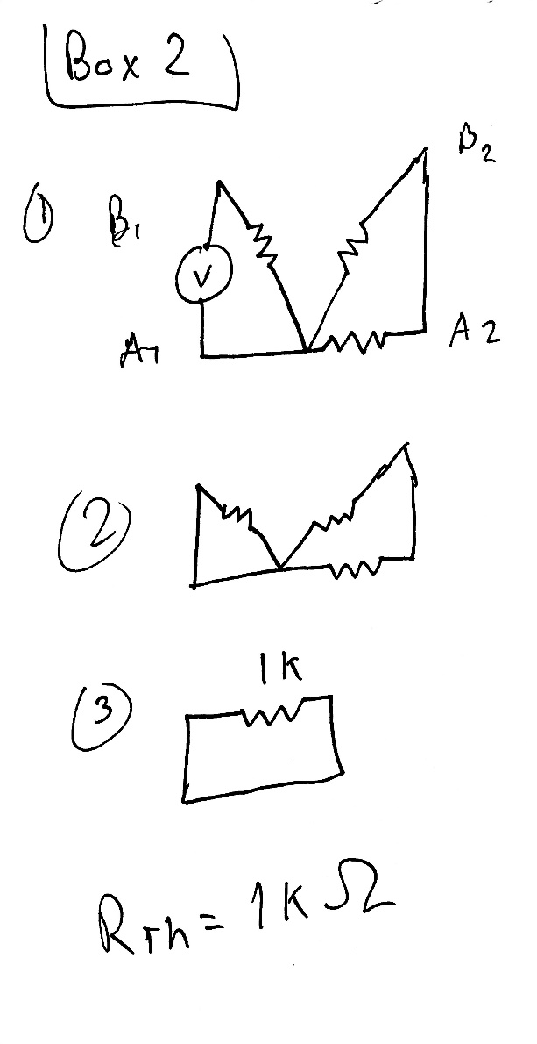

*Box 3*

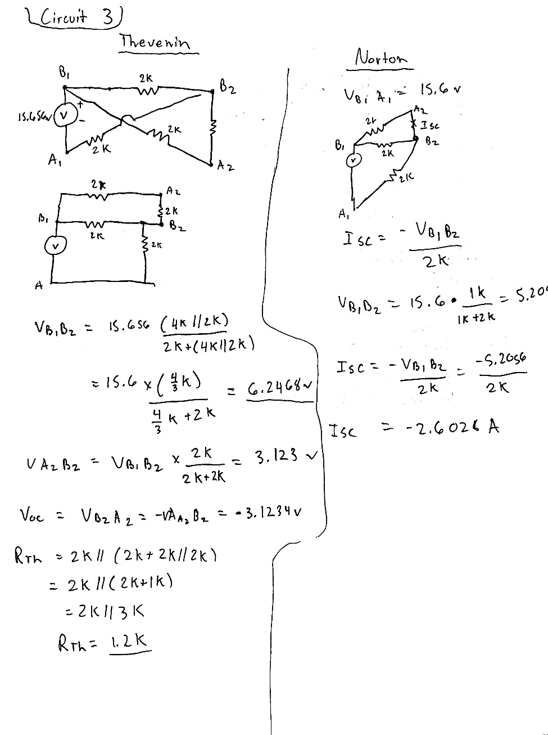

# Exercise 5

In exercise 5, we were asked knowing what we do about this specific black box, is it possible to measure the Thevenin resistance at B1-B2 directly from the black box?

Yes, we are able to measure RTh  directly when we know the voltage and contents of the box.

# Conclusion

This lab was used as an overview of Thevenin’sand Norton’s theorem. We were given circuits and asked to calculate various things using Thevinin equations and then verify it through Multisim. I did have some struggles with this lab. The TA helped explain some things before we started so the lab was clearer.

# Bibliography

[1] Nelms, R. Mark, and Elizabeth Devore. *Recitation & MultiSim: Thevenin’s and Norton’s Theorems*. 2016, p. 5, Accessed 4 Sept 2019.